~~!~~

**ERP Software Requirements**

**Specification**

**For**

**SOFT DRINKS MANUFACTURING COMPANY**

**Prepared by Group 11**

**August 27, 2024**

**Software Requirements Specification for ERP SYSTEM**

**1.** **INTRODUCTION** 2

**2. OVERALL DESCRIPTION** 3

**3.** **EXTERNAL INTERFACE REQUIREMENTS** 5

**3.0 User Interfaces** 5

**3.1** **Software Interfaces** 7

**3.2** **Customer Requirements** 7

**4.** **SYSTEM FEATURES** 7

**5.** **OTHER NONFUNCTIONAL REQUIREMENTS** 12

**APPENDIX** 13

# **INTRODUCTION**

**1.0 Purpose**

The purpose of this project is to design and implement a comprehensive ERP system for a mini manufacturing company specializing in soft drink production. The ERP system aims to integrate various business processes, enhance operational efficiency, streamline workflows, and support informed decision-making.

**1.1 Intended Audience and Reading Suggestions**

This document is intended for the system's end-users, stakeholders, system developers, and the project manager.

- End-users: Individuals within the company who will interact with the ERP system daily to manage operations.

- Stakeholders: Company executives and department heads who require insights into how the system will support business goals.

- System Developers: Professionals who will be responsible for building and maintaining the ERP system.

- Project Manager: The individual overseeing the project’s execution, ensuring that it meets the company's requirements and is delivered on time.

The remainder of this document includes several key sections. The second section provides an overview of the system's architecture and modules, detailing the interactions between different business processes. This section is useful for both developers and stakeholders. The third section outlines the specific requirements of each module, providing detailed guidance for developers. Subsequent sections cover non-functional requirements such as security, scalability, and integration, essential for both the project manager and stakeholders.

1.2 Project Scope

The ERP system is designed as a modular, scalable solution that integrates key business processes including Inventory Management, Production Planning and Control, Sales and Order Processing, Purchasing and Supplier Management, Finance and Accounting, Human Resources Management, and Reporting and Analytics. The system will provide a user-friendly, secure, and efficient platform for the company's operations, supporting future growth and additional functionalities as needed.

# **2. OVERALL DESCRIPTION**

**2.0 Product Perspective**

The ERP system is designed to provide a digital solution that integrates and automates key business processes within a mini manufacturing company focused on soft drink production. The product aims to improve operational efficiency, enhance decision-making capabilities, and provide a seamless workflow across departments.

**2.1 Product Functions**

The ERP system will support the following primary functions:

- Inventory Management: Track and manage raw materials and finished goods.

- Production Planning and Control: Schedule and monitor production processes.

- Sales and Order Processing: Manage customer orders and sales data.

- Purchasing and Supplier Management: Handle procurement and supplier relationships.

- Finance and Accounting: Automate financial transactions and generate financial reports.

- Human Resources Management: Manage employee records, payroll, and benefits.

- Reporting and Analytics: Provide real-time data analysis and generate reports.

**2.2 User Classes and Characteristic**

Users of the ERP system are categorized into several groups:

- End-Users: Employees who will use the system to perform daily operations, such as inventory management, sales processing, and production monitoring.

- System Administrator: Responsible for the overall management of the system, including user access control, system configuration, and data management.

- Management: Executives and department heads who will use the system's analytics and reporting features to make informed decisions.

**Characteristics:**

- End-Users: Typically have varying levels of technical expertise and require a user-friendly interface to perform their tasks efficiently.

- System Administrator: Requires a deep understanding of the system's architecture and functionalities to manage and troubleshoot the ERP system effectively.

- Management: Requires easy access to high-level data insights and reports to drive business decisions.

**2.3 Operating Environment**

The ERP system is designed to be a web-based application that can be accessed via any modern web browser. It is compatible with multiple operating systems, including:

- Window

- Linux (e.g., Ubuntu)

- Mac OS

The system will be hosted on a cloud platform or on-premises servers, depending on the company's infrastructure. It requires stable internet connectivity for remote access and data synchronization across departments.

**2.4 Design and Implementation Constraints**

The ERP system is developed using the following technologies:

- Frontend: React.js or Angular.js for dynamic user interfaces.

- Backend: Node.js or Django for server-side processing.

- Database: MySQL or PostgreSQL for data storage and management.

- Reporting: Tableau for advanced reporting and analytics.

**Constraints**

- The system requires a reliable database (e.g., MySQL) to store large volumes of business data securely.

- Integration with existing systems and hardware may require custom development and testing.

- The system must comply with industry-standard security protocols to protect sensitive business and employee data..

# **EXTERNAL INTERFACE REQUIREMENTS**

## **3.0 User Interfaces**

The GUI developed with HTML, CSS and JavaScript.

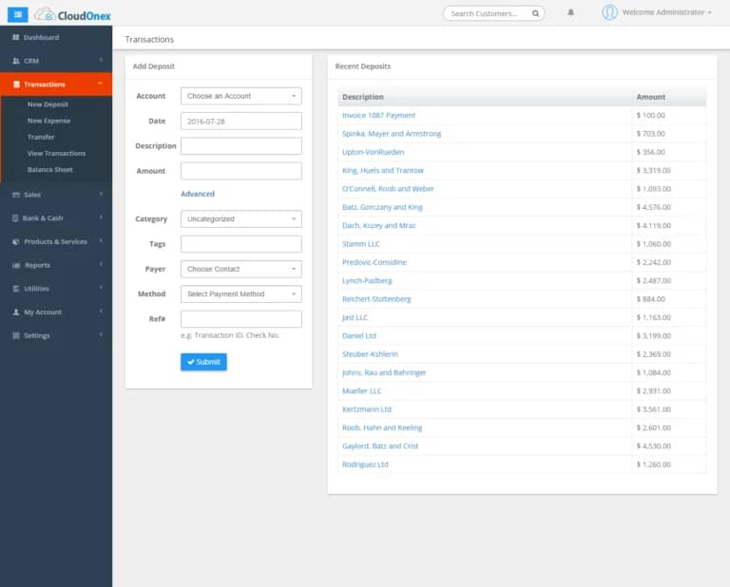

Figure 1 (transactions page)

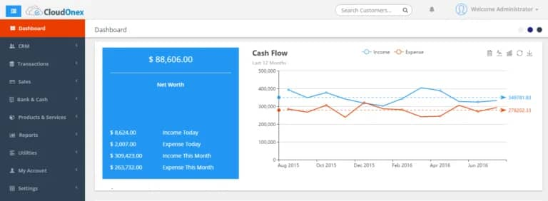

Figure 2 (dashboard)

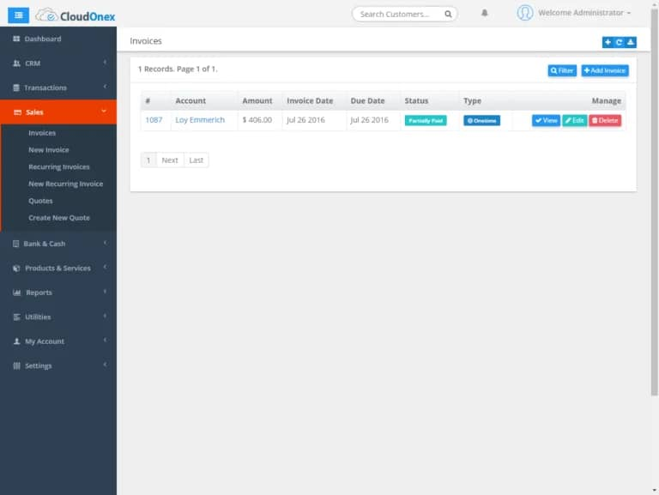

Figure 3 (sales page)

Figure 4 (Admin Dashboard)

## **Software Interfaces**

This platform connects to other software components. It uses MySQL for its database management. It runs on operating systems including Linux (Ubuntu etc…), Windows, Mac OS etc.

## **Customer Requirements**

From the users’ point of view, “the ERP, should be user friendly as its target audience might not be tech-savvy to utilize it”.

# **SYSTEM FEATURES**

**4. SYSTEM FEATURES**

This section outlines the features of the ERP system for the soft drink manufacturing company, providing detailed information on the system's functionalities and how they meet the needs of the company.

**4.1 Inventory Management**

**Feature: Real-time Inventory Tracking**

- Description : The system tracks inventory levels of raw materials and finished goods in real-time, providing updates whenever stock levels change due to production, sales, or restocking activities.

- Requirements : Users should be able to view current stock levels, set minimum stock thresholds, and receive alerts when stocks are low.

- Input : Stock level data from warehouse activities (e.g., goods received, goods issued).

- Output : Updated inventory levels displayed on the dashboard, low stock alerts.

**Feature: Barcode Scanning Integration**

- Description : Integrate barcode scanning for quick and accurate inventory updates.

- Requirements : The system should support barcode scanners to streamline inventory management.

- Input : Barcode scans of items being added or removed from inventory.

- Output : Automatic update of inventory records.

**4.2 Production Planning and Control**

**Feature: Production Scheduling**

- Description : Allows for the creation and management of production schedules based on demand forecasts.

- Requirements : The system should allow users to input production targets, allocate resources, and monitor progress.

- Input : Production orders, demand forecasts, resource availability.

- Output : Detailed production schedules, resource allocation reports.

**Feature: Real-time Production Monitoring**

- Description : Monitor production processes in real-time to track progress and address any issues immediately.

- Requirements : Integration with production machinery to capture data on production status.

- Input : Data from production machines, manual inputs from operators.

- Output : Real-time production reports, alerts for any issues or delays.

**4.3 Sales and Order Processing**

Feature: Order Management

- Description : Manage customer orders from placement to delivery, ensuring timely processing and accurate records.

- Requirements : The system should handle order entry, processing, invoicing, and delivery scheduling.

- Input : Customer order details, product availability, delivery schedules.

- Output : Order confirmation, invoice generation, delivery schedules.

Feature: Sales Reporting

- Description : Generate detailed sales reports to analyze performance and forecast future sales.

- Requirements : The system should allow users to generate customized sales reports by product, region, and time period.

- Input : Sales data, customer data.

- Output : Sales performance reports, forecasts.

**4.4 Purchasing and Supplier Management**

Feature: Supplier Management

- Description : Manage supplier data, track performance, and maintain relationships.

- Requirements : The system should allow users to store and manage supplier information, track orders, and evaluate performance.

- Input : Supplier data, purchase orders, delivery performance data.

- Output : Supplier performance reports, purchase order records.

Feature: Automated Reordering

- Description : Automate the reordering process based on inventory levels and supplier agreements.

- Requirements : The system should automatically generate purchase orders when stock levels fall below a predefined threshold.

- Input : Inventory levels, supplier agreements.

- Output : Automatic purchase order generation, restocking alerts.

**4.5 Finance and Accounting**

Feature: Automated Invoicing

- Description : Automate the creation and sending of invoices based on sales and order processing.

- Requirements : The system should automatically generate invoices for completed sales orders.

- Input : Completed sales order data.

- Output : Generated invoices, accounts receivable updates.

Feature: Financial Reporting

- Description : Generate financial statements and reports to support accounting and financial decision-making.

- Requirements : The system should allow users to generate balance sheets, income statements, and cash flow statements.

- Input : Financial transactions, sales data, expense reports.

- Output : Financial statements, financial performance reports.

**4.6 Human Resources Management**

Feature: Employee Records Management

- Description : Manage employee records including personal details, job roles, and payroll information.

- Requirements : The system should allow HR staff to store and update employee records securely.

- Input : Employee personal data, job details, payroll information.

- Output : Updated employee records, payroll reports.

Feature: Payroll Processing

- Description : Automate payroll processing based on attendance and salary data.

- Requirements : The system should calculate employee salaries, deductions, and generate payslips.

- Input : Attendance records, salary data.

- Output : Processed payroll, generated payslips.

**4.7 Reporting and Analytics**

Feature: Customizable Dashboards

- Description : Provide users with customizable dashboards to display key performance indicators (KPIs) and other critical data.

- Requirements : Users should be able to customize their dashboards to display the most relevant data for their role.

- Input : User preferences, system data.

- Output : Personalized dashboards, KPI visualizations.

**Feature: Real-time Analytics**

- Description : Perform real-time data analysis to provide insights into business performance.

- Requirements : The system should support real-time data processing and analytics.

- Input : Sales data, production data, financial data.

- Output : Real-time performance reports, trend analysis.

**4.1 Functional Requirements**

Functional Requirement 1:

- ID : REQ-1

- Purpose : User Authentication

- Primary Actor : All Users (End-Users, Admins, Management)

- Requirements : Each user must log in with a unique username and password.

- Input : Username and password entered on the login screen.

- Output : User gains access to the system if login credentials are validated.

- Exceptions : If incorrect credentials are entered, the system should deny access and display an error message.

- Dependency : The authentication module must be connected to the user database and encryption protocols.

Functional Requirement 2:

- ID : REQ-2

- Purpose : Inventory Management

- Primary Actor : Inventory Managers, Warehouse Staff

- Requirements : Users should be able to add, update, and remove inventory items.

- Input : Item details, stock levels, warehouse location.

- Output : Updated inventory records displayed in the system.

- Exceptions : The system should not allow duplicate entries for the same item in the same warehouse.

- Dependency : This function depends on the database schema for inventory and the UI module for data entry.

# **OTHER NONFUNCTIONAL REQUIREMENTS**

**5.0 Performance Requirements**

* **Database Requirements**: The ERP system requires MySQL or PostgreSQL to be installed on the server. For optimal performance, the database should be configured to handle large volumes of transactions, with appropriate indexing and optimization strategies in place.
* **Server Configuration**: The system is designed to run on a local or cloud-based server. For Windows users, the server must be configured with standard authentication to successfully run localhost.
* **Response Time**: The system should respond to user inputs within 2-3 seconds for standard operations like data entry, retrieval, and report generation.
* **Scalability**: The system should be able to handle increased loads as the company grows, including more users, larger datasets, and additional modules.
  1. **Security Requirements**
* **Data Protection**: The ERP system must implement encryption protocols (e.g., SSL/TLS) to ensure that data transmitted between users and the server is secure.
* **User Authentication**: The system must authenticate users using secure methods, such as two-factor authentication (2FA), and ensure that only authorized users can access the system.
* **Role-Based Access Control (RBAC)**: The system must enforce role-based access control, ensuring that users can only perform tasks as permitted by their assigned roles and privileges.
* **Data Backup**: Regular automated backups must be performed to prevent data loss, and backups should be securely stored in a separate location.
  1. **Software Quality Attributes**
* **Reliability**: The ERP system must be reliable, consistently meeting its specified requirements and performing its functions without failure. It should handle errors gracefully and ensure data integrity.
* **Maintainability**: The system must be maintainable, with a modular design that allows for easy updates, bug fixes, and enhancements. The use of version control (e.g., Git) enables efficient management of different versions and collaboration among developers.
* **Testability**: The system should be designed with testability in mind, allowing for automated and manual testing. Clear logging and debugging features should be in place to trace issues and ensure that the platform functions as intended.
* **Usability**: The system should have a user-friendly interface that allows users of varying technical skills to navigate and perform their tasks efficiently. Training materials and user guides should be provided to support end-users.
* **Portability**: The ERP system should be portable across different operating systems (Windows, Linux, Mac OS) and environments (local servers, cloud-based platforms).
* **Efficiency**: The system should efficiently utilize resources, including CPU, memory, and network bandwidth, to ensure smooth operation even under heavy load conditions.

# **APPENDIX**

* 1. **Acronyms and Abbreviations**
* **ERP**: Enterprise Resource Planning
* **KPI**: Key Performance Indicator
* **RBAC**: Role-Based Access Control
* **2FA**: Two-Factor Authentication
* **SSL/TLS**: Secure Sockets Layer / Transport Layer Security
* **UI**: User Interface
* **REQ**: Requirement
* **DBMS**: Database Management System
  1. **Glossary**
* **End-User**: A user who interacts with the system for daily operations, such as managing inventory or processing orders.
* **System Administrator**: The individual responsible for managing and maintaining the ERP system, including user accounts, data security, and system configurations.
* **Management**: Executives or department heads who use the ERP system’s reporting and analytics features to make strategic business decisions.
* **Inventory Management**: The process of overseeing and controlling the ordering, storage, and use of components or products that the company will use in production or sell.
* **Production Planning and Control**: The process of planning and controlling the production process to ensure that production goals are met efficiently.
* **Sales and Order Processing**: The process of handling customer orders from receipt to fulfillment.
* **Purchasing and Supplier Management**: The process of acquiring goods and services from suppliers and managing supplier relationships.
* **Finance and Accounting**: The management of financial transactions, including invoicing, payroll, and financial reporting.
* **Human Resources Management**: The management of employee records, payroll, and benefits within an organization.
* **Reporting and Analytics**: The process of collecting, analyzing, and presenting data to help make informed business decisions.
  1. **References**
* **Software Development Standards**: Guidelines and best practices used during the development of the ERP system.
* **Security Protocols**: Industry standards for securing software systems, including encryption methods and authentication mechanisms.
* **Database Management Documentation**: References for the configuration and management of MySQL/PostgreSQL databases.

**D. Tools and Technologies**

* **Frontend Technologies**: React.js, Angular.js, HTML, CSS, Bootstrap
* **Backend Technologies**: Node.js, Django, PHP, JavaScript
* **Database Management Systems**: MySQL, PostgreSQL
* **Version Control**: Git
* **Analytics and Reporting**: Tableau
  1. **Document Revision History**

| **Version** | **Date** | **Description** | **Author** |
| --- | --- | --- | --- |
| 1.0 | 2024-08-23 | Initial draft of ERP system design document | [Your Name] |
| 1.1 | 2024-08-25 | Updated with additional system features | [Your Name] |
| 1.2 | 2024-08-26 | Final version after stakeholder review | [Your Name] |
|  |  |  |  |